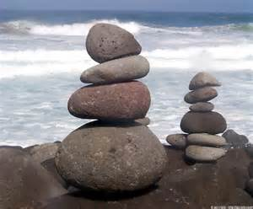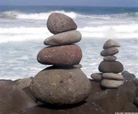**Year 3 Science Homework**

**Rocks**

**Given out: 4th December 2014 Handed in: 9th December 2014**

Next week we will be beginning our science learning about ‘Rocks’. Your homework this week is to think about what you know and what you would like to find out about rocks. Can you also spot things that are made out of rocks around your home or the local environment?

What we know

What we would like to find out

**Rock Detectives**

Can you find materials made from rocks used in and around our local environment?

|  |  |  |
| --- | --- | --- |
|  |  |  |
|  |  |  |
|  |  |  |

Write and draw about what you have found

**Useful words:** sand, rock, concrete, clay, tiles, glass, metal, bricks, tiles, rigid, strong, waterproof, hard, attractive