Homework 16.4.15
Spellings
This week, we have learnt the next keyword list. Make sure you understand what they mean as well as spelling them correctly.
knowledge, library, material, medicine, mention, minute
Grammar
We’ve played ‘consequences’ in numeracy and literacy this week. You must work with a partner or a small group and each have a strip of paper. You write one thing, fold it over, pass it on and then write the next part. In literacy, we have been looking at powerful word choices and different words types for our own Cinquain poems.
Step 1: Decide on the word order which means that a sentence will make sense. E.g. You might have adjective, noun, verb, adverb.
Step 2: You call out the word type and everyone playing writes down an example.
Step 3: Fold over the paper and pass it on to the next person.
Step 4: When you have written each word down, unfold them and read out the sentence. Who has the silliest?
We have played this in class, so we hope you can explain the game well!

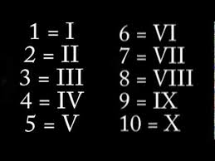
Maths
We looked at Roman Numerals and how to write
numbers up to 100. We found that they are not very
useful when you’re using the column method of addition!
Can you write 3 addition facts just using Roman numerals?
You only have to total up to 100 but can work on larger
Numbers if you’re feeling confident.

