Homework 21.1.16
Spellings
This week we have looked at the ‘im’ prefix and how to use it to mean ‘not’ when used with a word beginning with b, p or m. Practise your spellings and make sure you understand what they words mean.
immature impatient immobile imbalance
Maths
We have used our division skills to divide 4 digit numbers using the ‘bus stop’ formal method. Choose the task appropriate for you. There are 3 parts to the first task so you can choose 2, 3 or 4 digit numbers.
The second task makes you think about the estimating skills you could use.
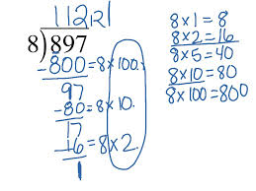
Task 1
57 ÷ 4, 43 ÷ 3, 61 ÷ 5
475 ÷ 4, 637 ÷ 6, 157 ÷ 3,
5725 ÷ 4, 4278 ÷ 6, 3410 ÷ 7
Task 2
Estimate the quotient of:
6852 ÷ 6, 2078 ÷ 7, 3354 ÷ 4
Clue: Use the first two digits to consider which is the nearest ‘easy’ multiple.

Grammar
We have used the first person (I) within our writing and changed third person (they) extracts into first person. Here is a picture of fish! Choose one of the fish or an object (such as the bowl or food) and write about the event from their point of view.
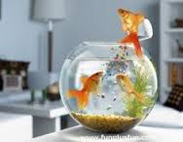

Homework 21.1.16
Spellings
This week we have looked at the ‘im’ prefix and how to use it to mean ‘not’ when used with a word beginning with b, p or m. Practise your spellings and make sure you understand what they words mean.
immature impatient immobile imbalance
Maths
We have used our division skills to divide 4 digit numbers using the ‘bus stop’ formal method. Choose the task appropriate for you. There are 3 parts to the first task so you can choose 2, 3 or 4 digit numbers.
The second task makes you think about the estimating skills you could use.
Task 1
57 ÷ 4, 43 ÷ 3, 61 ÷ 5
475 ÷ 4, 637 ÷ 6, 157 ÷ 3,
5725 ÷ 4, 4278 ÷ 6, 3410 ÷ 7
Task 2
Estimate the quotient of:
6852 ÷ 6, 2078 ÷ 7, 3354 ÷ 4
Clue: Use the first two digits to consider which is the nearest ‘easy’ multiple.

Grammar
We have used the first person (I) within our writing and changed third person (they) extracts into first person. Here is a picture of fish! Choose one of the fish or an object (such as the bowl or food) and write about the event from their point of view.

