Homework 28.1.16
Spellings
This week we have looked at the ‘ir’ prefix and how to use it to mean ‘not’ when used with a word beginning with r. Practise your spellings and make sure you understand what they words mean.
irregular irresponsible irresistible irreversible
Maths
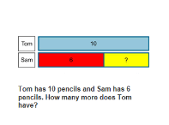
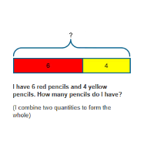
We have developed our worded problem work using bar models. We’ve worked really hard on this because we want to master it in order to support very difficult worded problems. We have had to understand that each bar model has a ‘whole’ and ‘part’ and have used an image to put the values that we know on, then using it see how to calculate the missing number.

The size of number is not important – it is the concept of how to use the model. We will be moving onto using them for multiplication and division problems and well as multi-step problems.
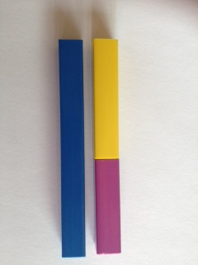
Here is an image of a bar model. Can you write 2 different worded problems that it could represent? Try to choose different operations (such as one addition and one subtraction)

Grammar
We developed our use of fronted adverbials by using phrases (a group of words) rather than just one adverb.
e.g. Like a kitten clawing at a trouser leg, the ivy gripped at the gnarled tree.
This fronted adverbial tells you ‘how’. They can also tell you ‘where’ or ‘when’. You must always use a comma after it and remember that your main clause should still make sense if you take the fronted adverbial away.
Describe teatime in your house using fronted adverbials (and no, it doesn’t have to be true!)

Homework 28.1.16
Spellings
This week we have looked at the ‘ir’ prefix and how to use it to mean ‘not’ when used with a word beginning with r. Practise your spellings and make sure you understand what they words mean.
irregular irresponsible irresistible irreversible
Maths
We have developed our worded problem work using bar models. We’ve worked really hard on this because we want to master it in order to support very difficult worded problems. We have had to understand that each bar model has a ‘whole’ and ‘part’ and have used an image to put the values that we know on, then using it see how to calculate the missing number.

The size of number is not important – it is the concept of how to use the model. We will be moving onto using them for multiplication and division problems and well as multi-step problems.
Here is an image of a bar model. Can you write 2 different worded problems that it could represent? Try to choose different operations (such as one addition and one subtraction)

Grammar
We developed our use of fronted adverbials by using phrases (a group of words) rather than just one adverb.
e.g. Like a kitten clawing at a trouser leg, the ivy gripped at the gnarled tree.
This fronted adverbial tells you ‘how’. They can also tell you ‘where’ or ‘when’. You must always use a comma after it and remember that your main clause should still make sense if you take the fronted adverbial away.
Describe teatime in your house using fronted adverbials (and no, it doesn’t have to be true!)

