Easter Homework Year 3
There are 15 activities (one for each day of the holiday). Complete the activities then stick the grid, and any extra sheets you use, in your homework book. Have fun!
Solve the problem:  Tara saved £125. John saved £88. They need £350 for their holiday. Do they have enough money? How do you know? | Write this sentence again but include a simile to make it more interesting to read:  The trees were tall. | Underline the main and subordinate clauses in these sentences:  The Black Knight liked playing chess, while plotting his evil ideas.  In the busy kitchen, Kitty Cobbler made her scones.
Fill in the missing numbers in this pattern:  1010, 1020, 1030, ____, 1050, 1060, ____, 1080, 1090, ____ | Solve these calculations:  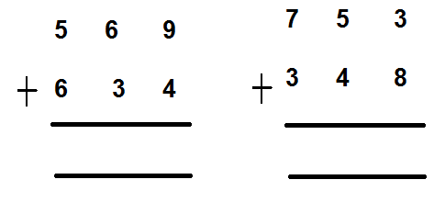 | Write this sentence again but include personification to make it more interesting to read:  The flower moved in the wind.
Write out your three times table: | Solve the problem:  Sarah’s mum is organising party bags for Sarah’s party. She has 9 party bags and 54 sweets. How many sweets will she need to put in each bag if she shares them equally? | Fill in the missing numbers in this pattern:  2900, 2800, 2700, ____, 2500, 2400, ____, 2200, 2100, ____, ____
Write this sentence again but include alliteration and an adverb:  The fish swam in the water. | Solve these calculations:  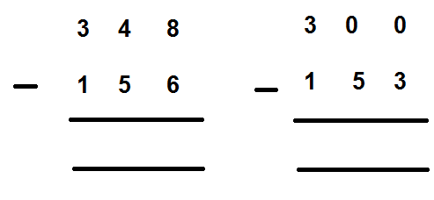 | Write a sentence for each of these types of punctuation:  . , ! ? “ “
Solve the problem:  Jack has 152 cool cards. His friend Tom has 5 times as many as Jack. How many cool cards does Tom have?  Challenge: How many do they have altogether? | Write your own sentence. Your sentence must have a main and a subordinate clause: | Write out your four times table:

