Homework 10.3.16
Spellings
This week’s spellings focus on the suffix –ous and how to use it in words where the -our in the word is changed to –or before the –ous is added. For example humour becomes humorous.
Vigorous Humorous Glamorous Harborous Honorous
Maths
We’ve started our fractions unit, so far looking at mixed numbers and simplifying fractions. Can you use your understanding of mixed numbers to solve these two questions?
Set one: Can you simplify this fraction and represent it in 3 different ways.
4
3

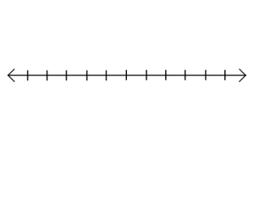
12

Set two: Can you now show this fraction on a number line starting at 3 ending at 4.

Play:
Continue to learn your lines and positions in the scenes, ready for our performance on Wednesday!

Homework 10.3.16
Spellings
This week’s spellings focus on the suffix –ous and how to use it in words where the -our in the word is changed to –or before the –ous is added. For example humour becomes humorous.
Vigorous Humorous Glamorous Harborous Honorous
Maths
We’ve started our fractions unit, so far looking at mixed numbers and simplifying fractions. Can you use your understanding of mixed numbers to solve these two questions?
Set one: Can you simplify this fraction and represent it in 3 different ways.
4
3

12

Set two: Can you now show this fraction on a number line starting at 3 ending at 4.

Play:
Continue to learn your lines and positions in the scenes, ready for our performance on Wednesday!

