Given out: Friday 27th January 2017. To be returned by: Wednesday 1thFebruary 2017.

Year 4 Homework

Visit our school blog: http://waalsy34.edublogs.org/

Follow our Twitter feeds for snap shots of our learning–

Miss Rushton @MissRAllSaints

Mr Holman @Y4AllSaintsWadd

Reading – Write the name of the text you read on each day!

Monday | Tuesday | Wednesday | Thursday | Friday | Saturday | Sunday

Numeracy

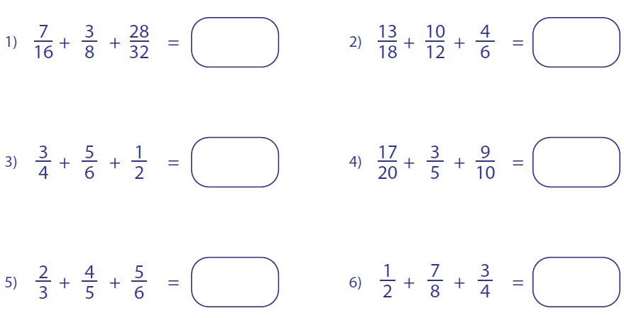
In Year 4 the children have been learning how to add fractions of different denominators. Complete the 6 question below.

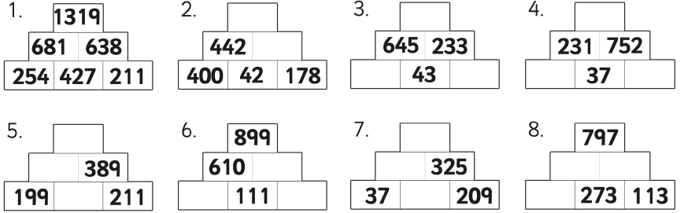
These are some addition and subtraction pyramids, the first one has been done for you to show how it works.

Literacy

In year 4 the children are learning about explanation texts. Time connectives are one of the features that are in this type of text. You need to explain how you would make a sandwich, underlining the time connectives that are used in your writing.
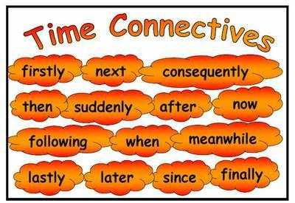

Challenge Add some adjectives and adverbs into your writing to up level your work.

