Developing a love of reading in KS2

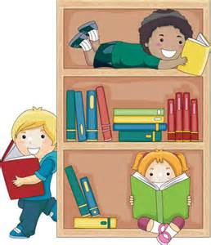

ALL SAINTS COMMUNITY PRIMARY SCHOOL

Dear Parents/Carers,

We hope that this leaflet will give you some helpful tips, so that you can support your child with their reading at home and also nurture and develop a lifelong love of reading.
If you have any questions please don’t hesitate to see your child’s class teacher.

Many Thanks

The Year 3/4 Team

Even though your child may now be a fluent reader, it is still important to hear them read aloud regularly.

At Key Stage 2 we encourage all our parents/carers to hear their children read at least four times a week. By continuing to actively share your child's reading you are giving it status and importance.

Although your child is probably well beyond the 'sounding out stage' they still need your support to continue to develop enjoyment and in-crease their understanding of more challenging texts.

In school, your child will be presented with texts, which are increasingly more difficult. In reading for pleasure, they should be choosing material, which stretches their reading. This may mean that some-times they do not fully understand all that they are reading. This is where your child will benefit from your support. You are in a position to help overcome any misunderstandings by talking about what they read to you and even your turn to read aloud. It is a good idea to share reading aloud as you can model pace, expression and fluency for your child.

On our weekly homework there are boxes for your child to tell us which books they are reading each week. This information helps us to guide children to make reading choices that are appropriate and challenging for them, also, we love to see which books children are enjoying at home!

Happy reading!

How can you help your child?

- Try to listen to your child read regularly. 15-20 minutes four times a week is much better than longer sessions once a week.
- Find a quiet place to share books where you can be comfortable.
- Talk about the book. The next page has a list of suggested questions and ideas to encourage your child to talk about the book.
- Ask questions, which encourage your child to give their own opinions for example, do you agree with this/the author’s opinion? How do you feel about this topic? Why? What do you think about/is your opinion of…? Can you support your view with evidence from the text?
- Encourage your child to read a range of texts such as newspapers, comics, poetry, non-fiction, etc.
- Share a book with your child. This may involve you reading to them or reading and talking together about the book.
- Play word games.
- Encourage children to read a series of books from a favourite author or books on topics of interest, especially to keep reluctant readers interested and reading.

Book Trust
Book Trust have compiled lists of amazing books for different age groups.
See the link below for great book ideas:
http://www.booktrust.org.uk/books/children/booklists/243/

Some helpful questions to use when reading a FICTION book…

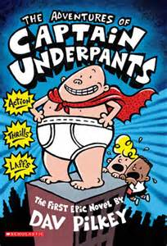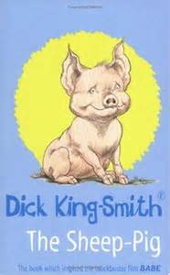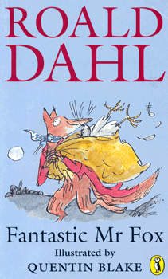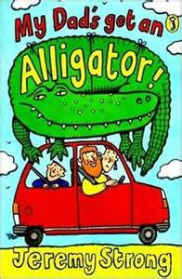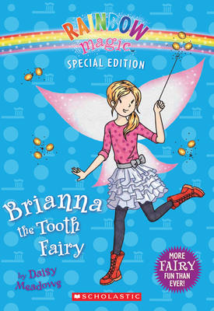

- Who was the character that…?
- Show me in the text where you found…?
- What is happening at this point/in this part of the story?
- Find one/two things that the main character did in this part of the story.
- Why was…important in this story?
- Tell me/write about what sort of character/person… was from the things they did/said in the story.
- What do you think…thoughts were at this point in the story/play? Use the text to help you think through your answer.
- If you were going to interview one of the characters, which questions would you ask and why?
- How did one of the characters change their ideas/ attitudes during the story/play? What was it that brought about this change?
- What do you think would have happened if…?
- Tell me about one important event that happened that could not be left out. Why is it so important? If…had not done…, how might this have changed other events in the story?
- How has the author organised the writing?
- Why does the author begin a new paragraph here?
- What is/are the main event(s) that happen(s) in this/ each para-graph?
- How has the author used words/phrases to make this character funny/sad/adventurous/clever/frightening/excited, etc?
- Which part of the story best describes the setting/ characters/action?
- Which words and/or phrases do this?
- Find and copy some words or phrases that show us that this character is special/helpful/adventurous/ unsure/worried, etc.
- How did the story make you feel? Why did it make you feel like this?
- Why do you think the author chose this particular setting for this story?
- How has the author started this in an interesting way?
- How does this make the reader want to read on?

Some helpful questions to use when reading a Non Fiction book…
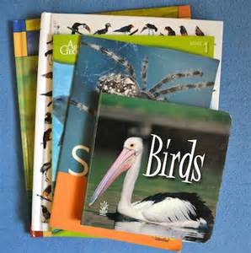
- Where can you find an important piece of information about …?
- Find two pieces of information that tell you about …
- What does this part of the text tell us about ….?
- Which part of the text tells us about …?
- How does this text layout help the reader?
- How does (a diagram/picture/caption) help you to understand the information on this/these pages?
- What is the purpose of the list/diagram/caption/ sub-headings in this text?
- Find something that is not a fact but the author’s opinion.

