Year 4 Homework

Given out: Friday 21st April 2017 To be returned by: Wednesday 3rd May 2017


Visit our school blog: http://waalsy34.edublogs.org/
Reading – Write the name of the text you read on each day!

MondayTuesday Wednesday ThursdayFridaySaturday Sunday

Maths

Below is an example of how to turn a fraction into a decimal:

Turn the following fractions into decimals:

Challenge!
Turn these decimals into fractions in their simplest form: 0.25 0.24 0.55 0.45 0.75

Handwriting

In order to be fully secure as a Year 4 writer children must join their writing with consistent sized letters.

Here are some examples of correct joining:

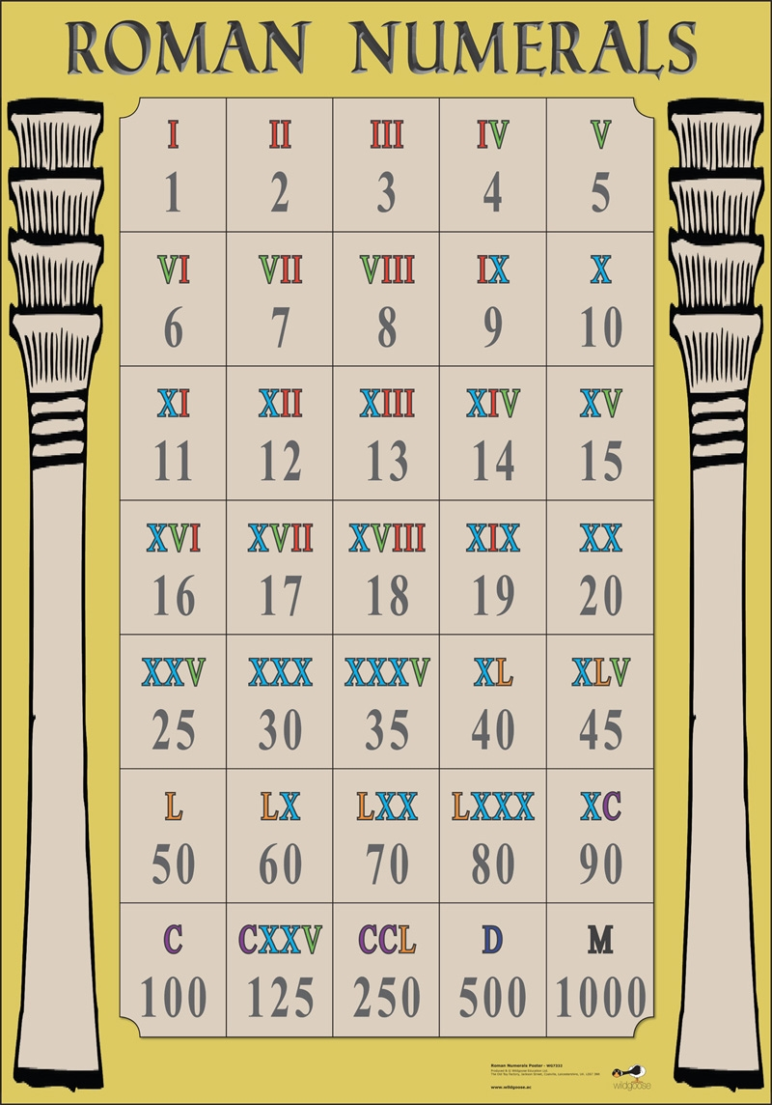

On the lines below practice joining every letter, apart from capitals, and make sure that your letters are consistently sized.

Use our Greek God names for practising! Zeus, Poseidon, Hera, Aphrodite, Athena, Apollo, Hermes, Hades.



Spellings!

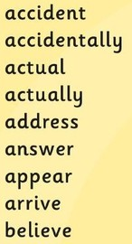
On Monday 1st May we will have a new Spelling Test in Year 4!

Each child has been given their individual score sheet, and will bring this home to you after each test to show you how they have performed.

Here are the words for our first test. Please help your child to practice them over the weekend.

Thank you.

