Year 4 Homework
Handed out: 27th September 2017
Spellings tested: 2nd October 2017
Spellings
Revise your spellings for the week and aim to use them in your discussions and writing. We have looked the ‘il’ and ‘ir’ prefix this week which also means ‘not’ or ‘into’ and is placed in front of words beginning with a ‘l’ or a ‘r’ respectively.
illegal illegible illogical illiterate illicit
irregular irrelevant irresponsible irrational
irresistible

Maths
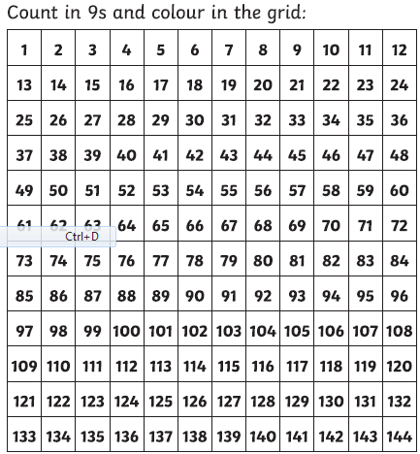
We are working on the 9 x tables this week. Complete the grid below.

Year 4 Homework
Handed out: 27th September 2017
Spellings tested: 2nd October 2017
Spellings
Revise your spellings for the week and aim to use them in your discussions and writing. We have looked the ‘il’ and ‘ir’ prefix this week which also means ‘not’ or ‘into’ and is placed in front of words beginning with a ‘l’ or a ‘r’ respectively.
illegal illegible illogical illiterate illicit
irregular irrelevant irresponsible irrational
irresistible

Maths
We are working on the 9 x tables this week. Complete the grid below.

