Year 4 Homework
Handed out: 4th October 2017
Spellings tested: 9th October 2017
Spellings
Revise your spellings for the week and aim to use them in your discussions and writing. We have looked at homophones this week (words with the same pronunciation but different meaning). Whilst these spellings may not seem too difficult, the focus is on using the correct word for the sentence and meaning intended.
meddle medal mist missed scene
seen bored board which witch
Using one of each the homophones, come up with some compound sentences (2 main clauses) and underline the homophone used.

Maths
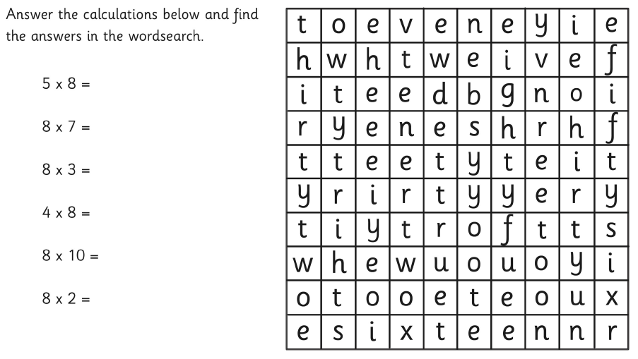

Year 4 Homework
Handed out: 4th October 2017
Spellings tested: 9th October 2017
Spellings
Revise your spellings for the week and aim to use them in your discussions and writing. We have looked at homophones this week (words with the same pronunciation but different meaning). Whilst these spellings may not seem too difficult, the focus is on using the correct word for the sentence and meaning intended.
meddle medal mist missed scene
seen bored board which witch
Using one of each the homophones, come up with some compound sentences (2 main clauses) and underline the homophone used.

Maths

